Voting in a federal
by-election
By mail
A SOCIAL STORY
24-1997 EF340 2026-03-30


I will vote at the by-election.
A by-election is held when there is an empty place in the House of Representatives.
When I vote, I will help choose a new representative for the area I live. This is called an electorate.
My representative will be part of the Australian government.

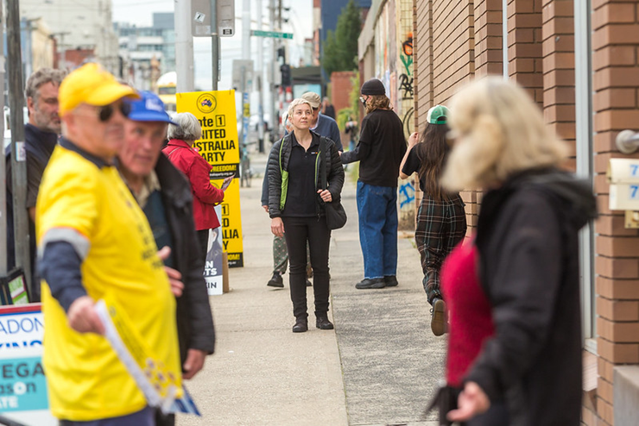
The government makes decisions on our behalf about how to run our country.
It is important for me to have a say about who makes the decisions that affect me.

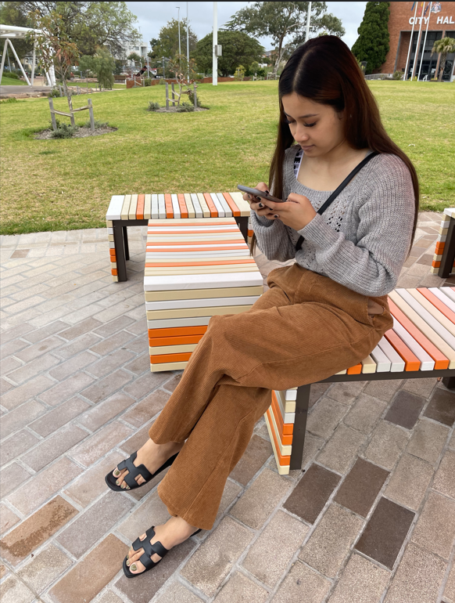
For me to make the best choice possible I can research the candidates or get advice from someone I trust.
My vote is secret. It’s my choice who I vote for, and I don’t need to tell anyone how I voted unless I want to.

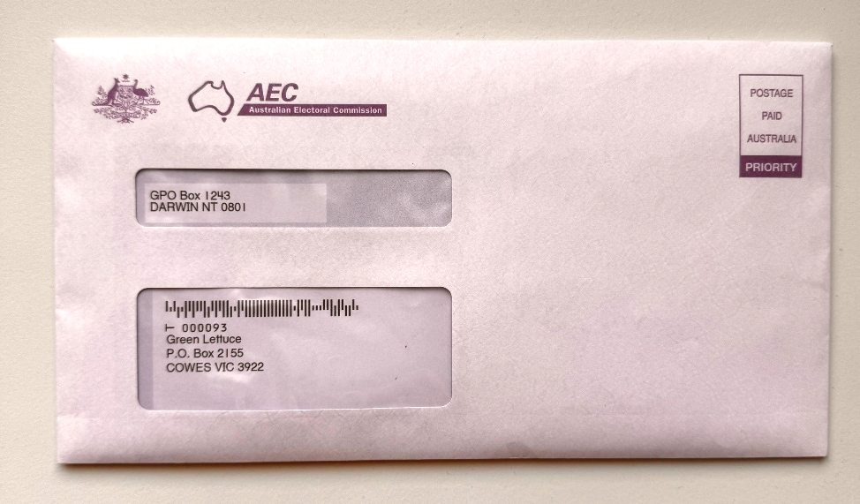
A polling place is a building where you can go to vote.
If I can’t vote in a polling place I can still vote.
I can receive my ballot paper through the mail.
This is called a postal vote.

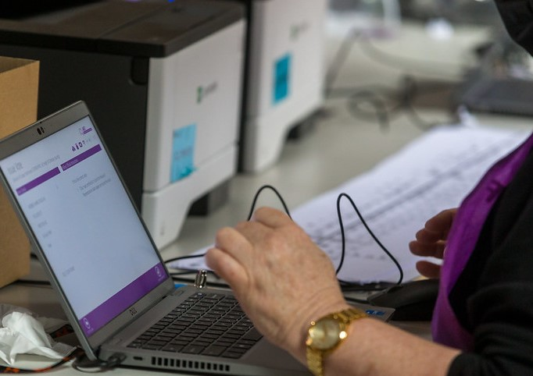
To receive a postal vote, I must apply by filling out a postal vote application.
I can do this by filling out an online application or by printing a paper form at www.aec.gov.au/pva

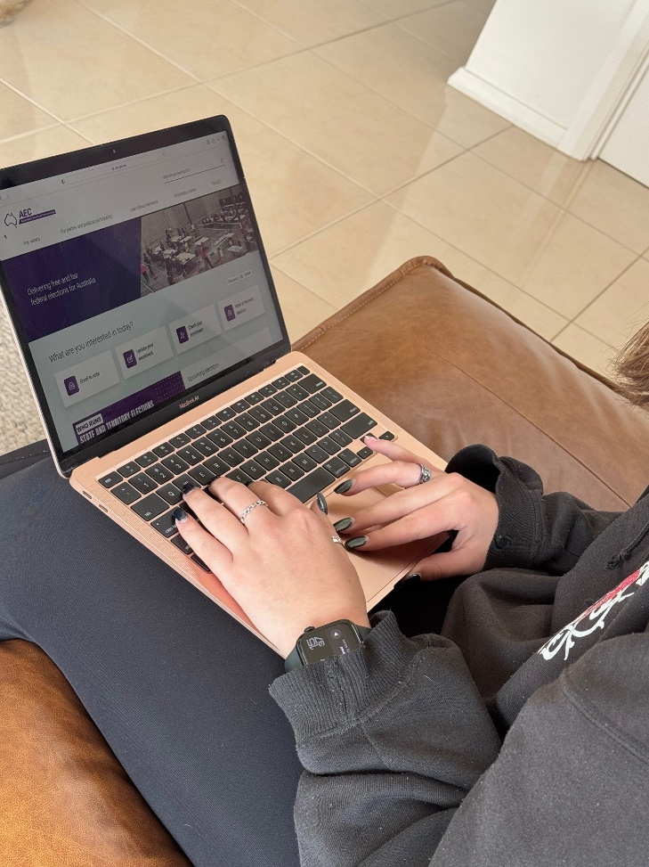
I can apply for a postal vote once the by-election date is announced.
It is important for me to submit my postal vote application as soon as possible but it must be submitted no later than 6pm on the Wednesday before voting day.

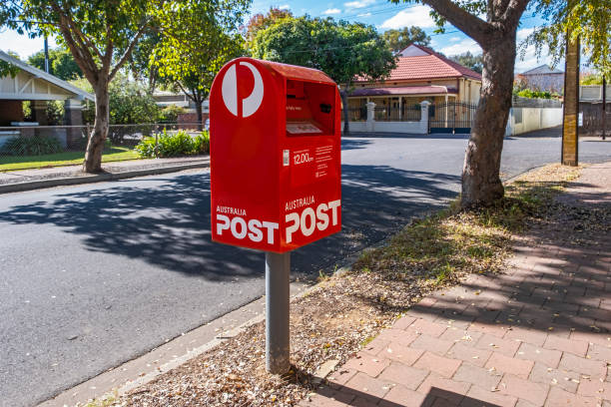
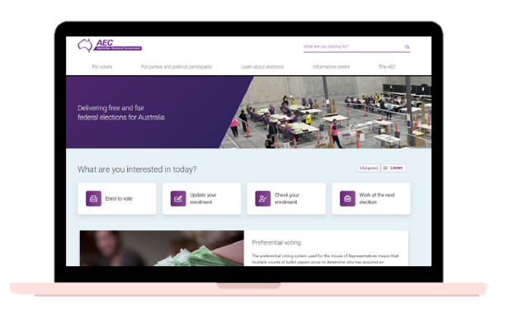

If I have filled out a paper application form, I can email my application to: applications@pva.aec.gov.au
I can send it in the mail:
Australian Electoral Commission
Reply Paid 9988
(My capital city)
(No stamp is needed if posted in Australia)
OR
In person:
aec.gov.au for my nearest office.

To fill out my postal vote application, I need to gather some information:
If I’m not sure how to do this, I can ask someone I trust for help. For example, a friend, carer or support worker.


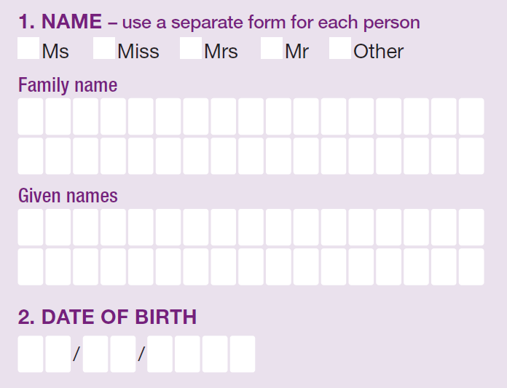
To complete a paper application form:
I will need to write my full name – this includes my family name (or surname) and then my given names.
I will also need to write the date I was born.

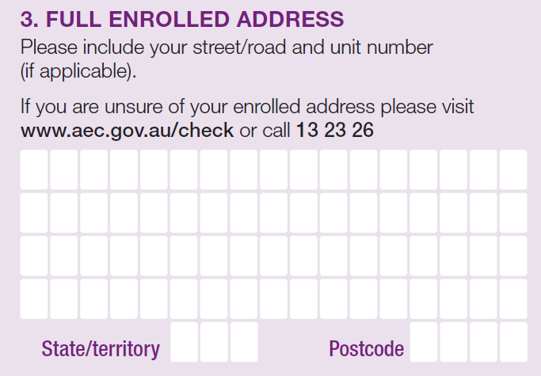
Then, I need to write my address.
This address is the same as the one I gave when I enrolled to vote.
It is probably the address where I live now.

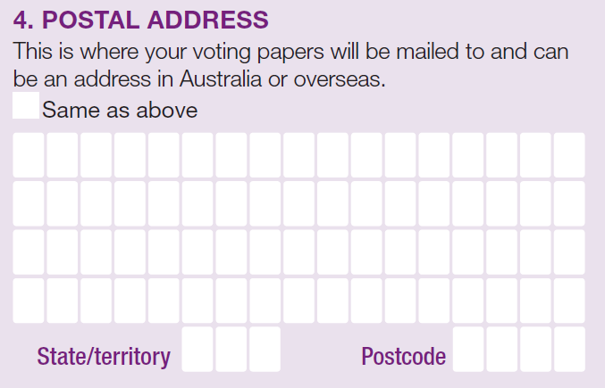
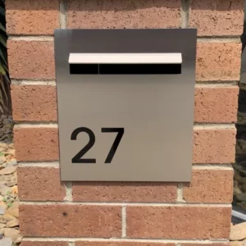
It is important my ballot paper gets to me so I need to answer the question, “Where should we send your ballot paper?”
I will write the address where I would like to receive my ballot paper.



In case the AEC need to contact me with any questions I need to give them:
- My email address
(if I have one)
- My mobile phone number
- My home phone number (if I have one)

My mobile phone and home phone number might be the same.


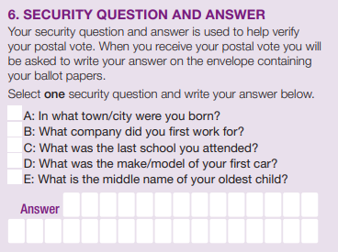
I will need to choose one of the five security questions.
This is like a password.
I can decide which security question and write my own answer.
I need to remember my answer.
I can choose to write the answer down somewhere safe if I am worried about forgetting it.

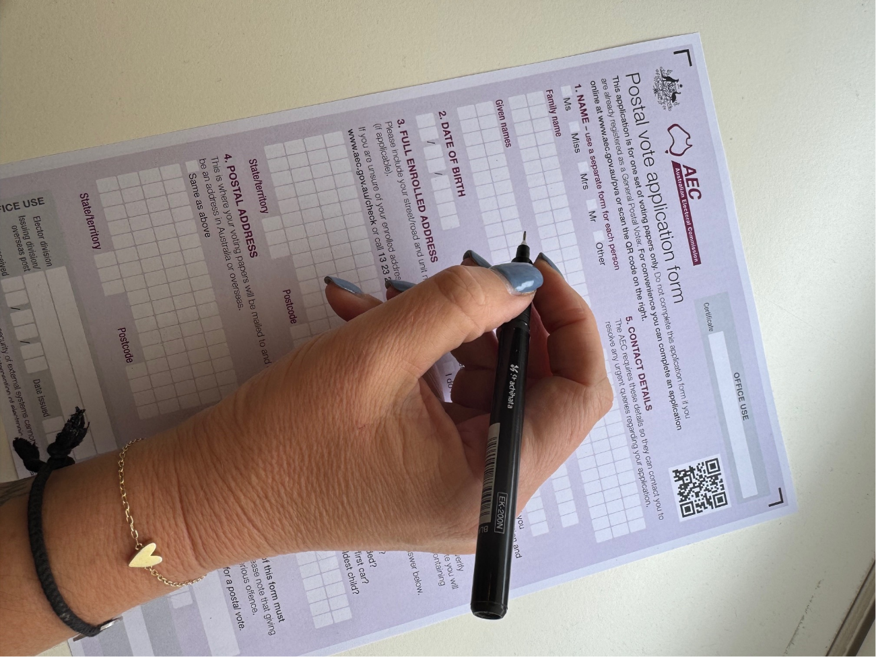

I will need to sign the application and put the date I signed it.

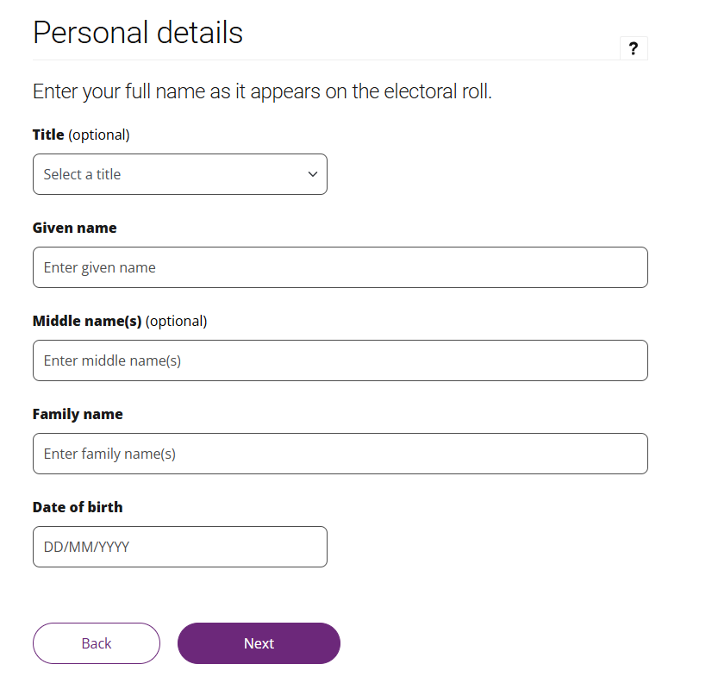

To complete the online application form:
I will need to fill in my full name – this includes my family name (or surname) and then my given names.
I will also need to enter the date I was born.

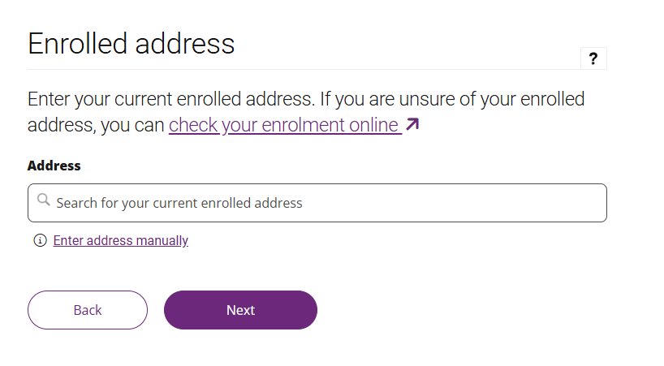

Then, I need to fill in my address.
This address is the same as the one I gave when I enrolled to vote.
It is probably the address where I live now.
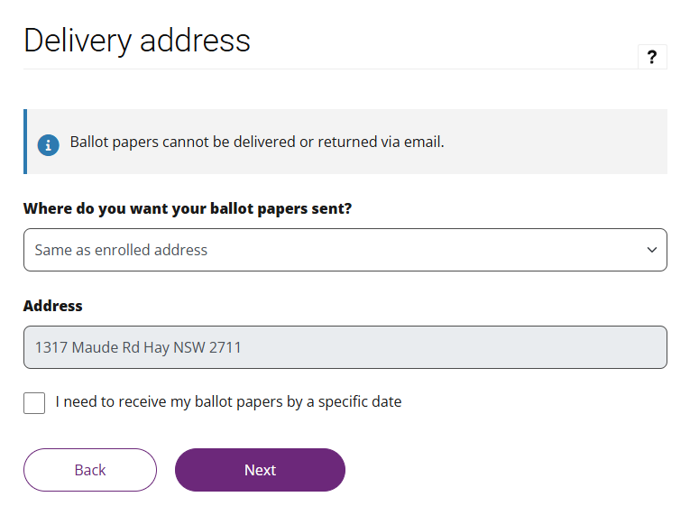

It is important my ballot paper gets to me so I need to answer the question, “Where should we send your ballot paper?”
I will write the address where I would like to receive my ballot paper.

In case the AEC need to contact me with any questions I need to give them:
- My email address
(if I have one)
- My mobile phone number
- My home phone number (if I have one)
My mobile phone and home phone number might be the same.
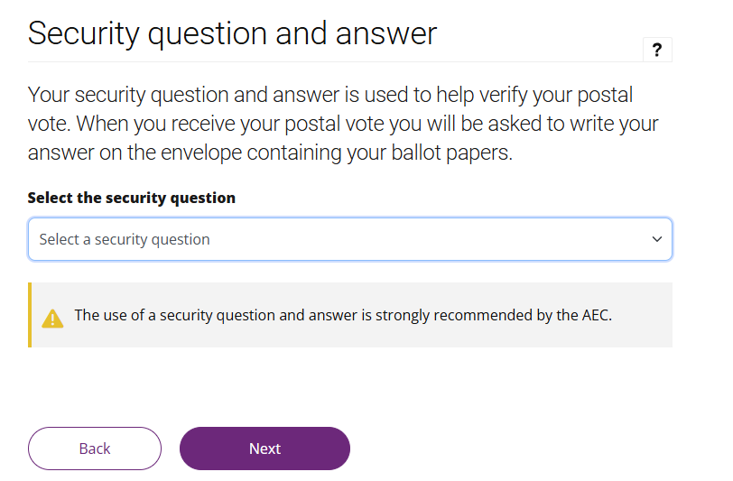
I will need to choose one of the five security questions.
This is like a password.
I can decide which security question and write my own answer.
I need to remember my answer.
I can choose to write the answer down somewhere safe if I am worried about forgetting it.
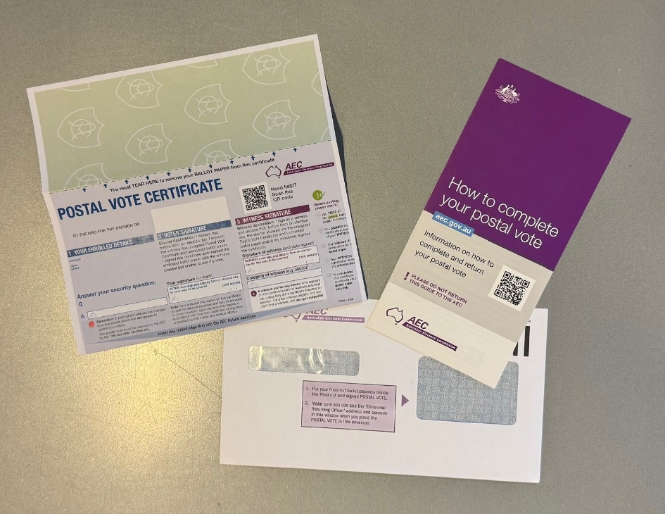
When it is time to vote, the AEC will send me my ballot paper.
I will get 1 green ballot paper along with a white envelope.
Attached to the green ballot paper I will have a blue certificate.
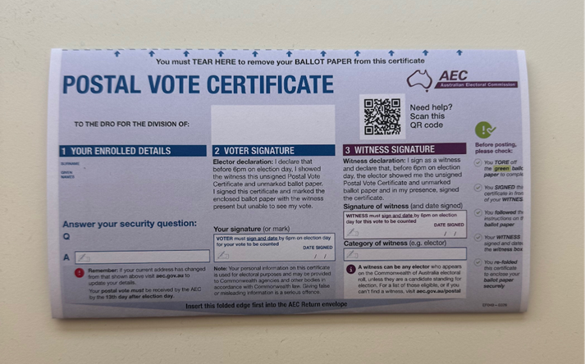
The blue certificate explains who I am.
It has my name, my address and the security question I chose.
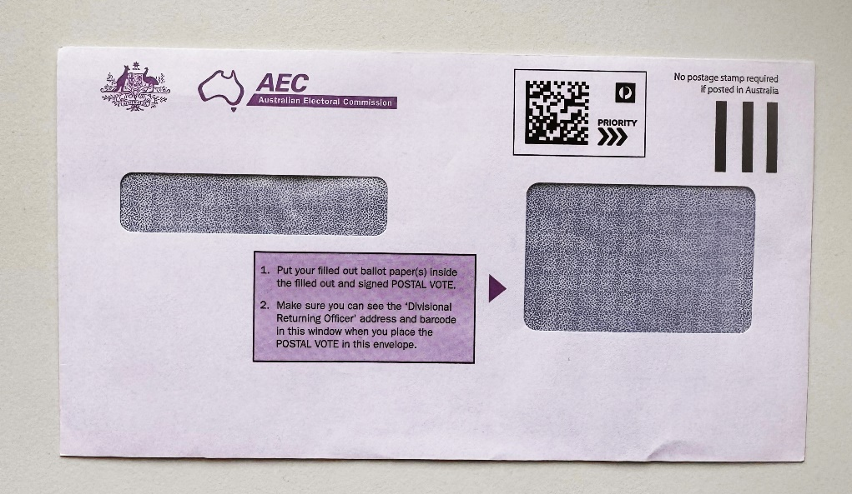
I will also get a white envelope to put my ballot paper and blue certificate in when I have finished voting.

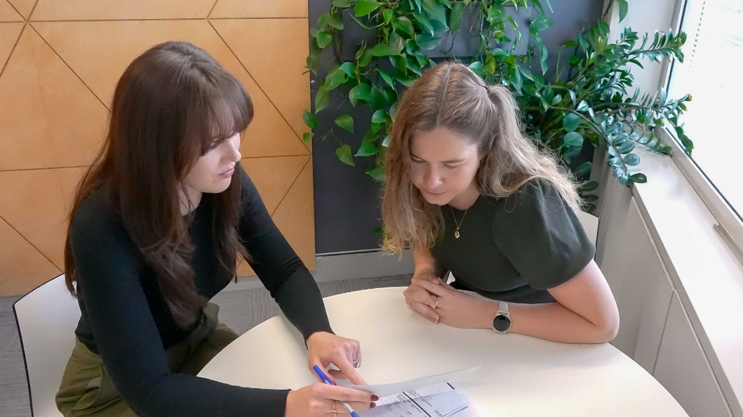
Before I vote I must ask someone to witness my blank ballot paper.
A witness might be someone I know, such as a family member, a friend or a support person.
My witness must be on the electoral roll which means they are able to vote.

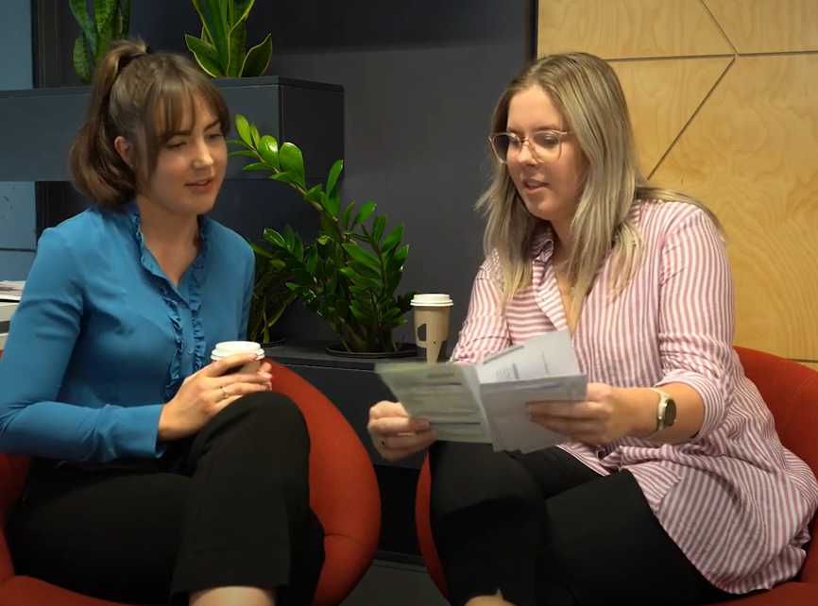
My witness needs to make sure I fill out my own ballot paper.
Before I fill it out, I will show my witness the blank ballot paper and the blue certificate.

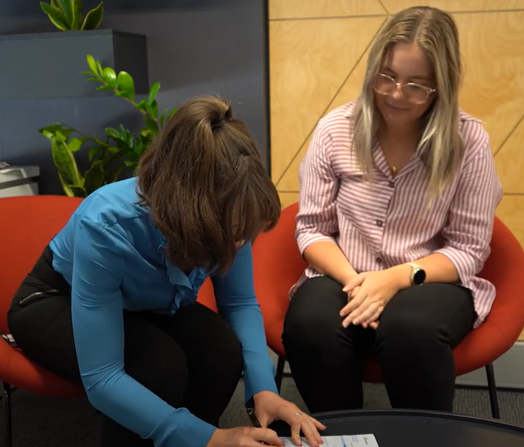
The blue certificate explains who I am and will include:
- My name
- My address
- The security question I gave the AEC in my application
I will answer the security question. I need to make sure that this is the same answer I gave on my application.
I may have written this answer down and kept it in a safe place.
After that I will sign my name.

If I am not sure what to do, I can ask my witness to help me fill in my blue certificate.

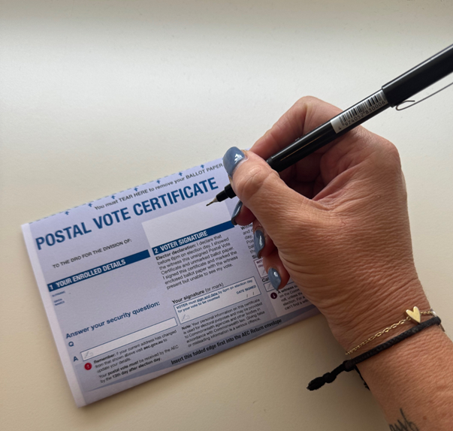
When I have finished filling out the blue certificate, my witness will need to sign it and write the date.
My witness and I must both sign the blue certificate by 6pm on voting day.
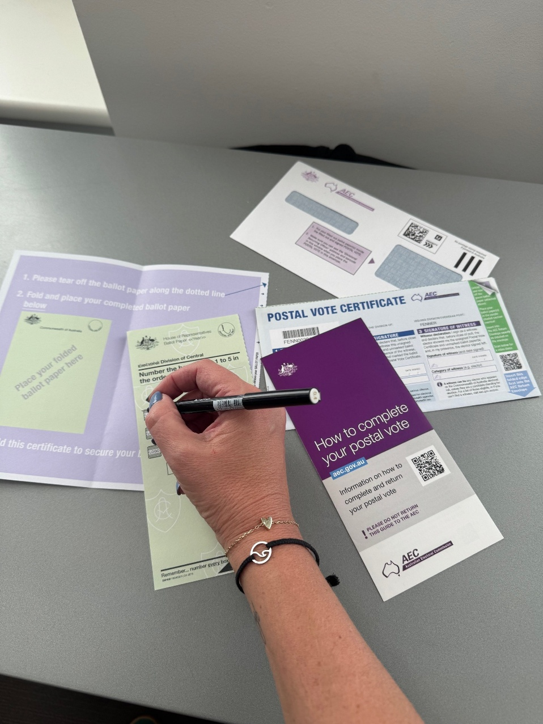
Now I am ready to vote.
I will fill out my ballot paper in the presence of my witness, but I also need to remember my vote is secret.
This means I need to fill out my ballot paper in a way that my witness cannot see who I am voting for.

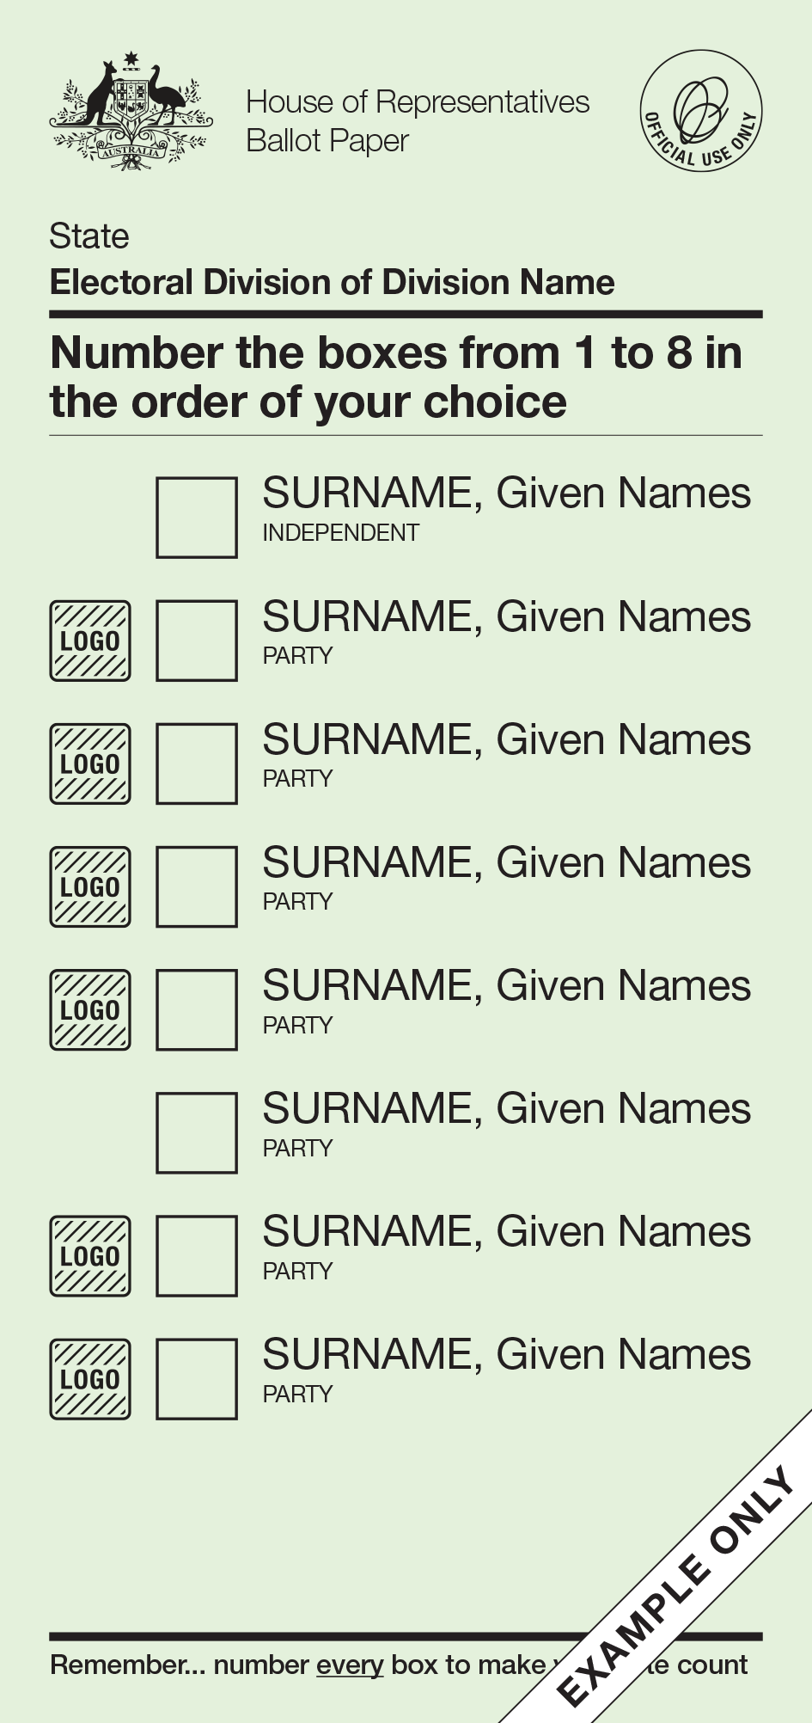

I will need to fill out the green ballot paper for the House of Representatives (also known as the Lower House).
A ballot paper is a form to show who you can vote for.

The green ballot paper has a list of all the candidates I can vote for. These are the candidates who want to be part of the House of Representatives.
If the candidate belongs to a political party, it will be written under their name.

On the green ballot paper, I need to write 1 in the box next to my favourite candidate, then 2 in the box for my second favourite.
There are instructions on the ballot paper telling me how many numbers to write.
I need to keep writing numbers in the order I choose until all the boxes are filled.
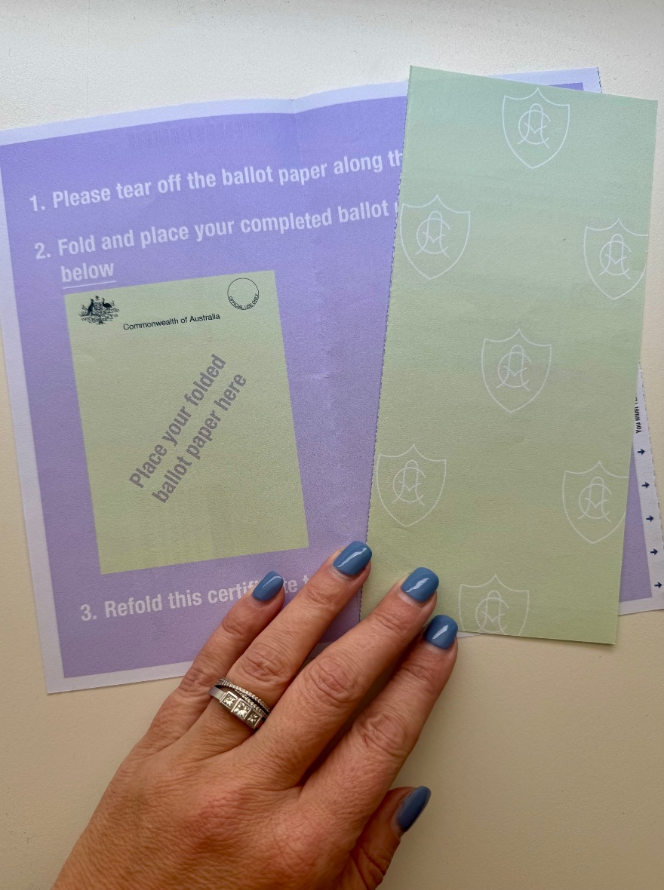
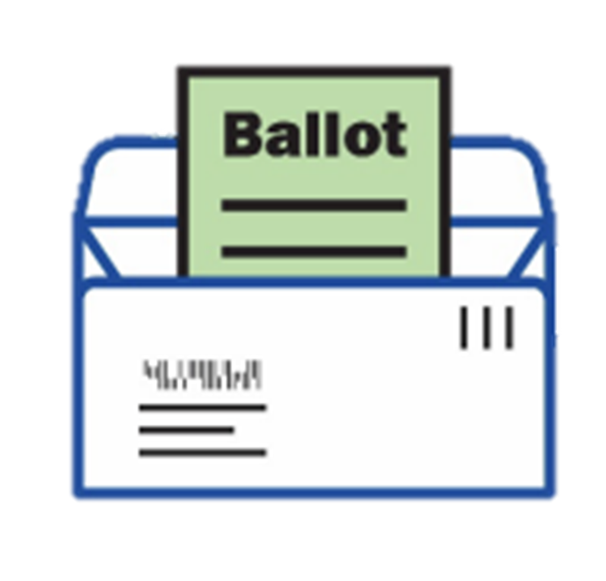
When I have filled out my ballot paper, I need to make sure it is placed in the white envelope correctly, ready to be mailed back to the AEC.
I can do this by:
- Folding the blue certificate in half
- Folding my ballot paper
- Putting my ballot paper inside the folded blue certificate
There are instructions to help me do this, but I can also ask someone I trust to help me if I am not sure.
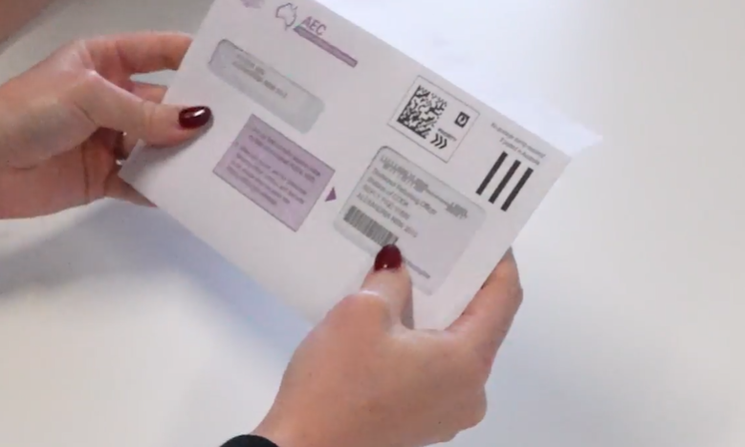

I will put the folded blue certificate with the ballot paper in the white return envelope and seal it.


I must complete my postal vote on or before 6pm on election day.
It is important that I get my ballot paper pack back to the AEC as soon as possible.
For my vote to count, it needs to arrive at the AEC no later than 13 days after the by-election.

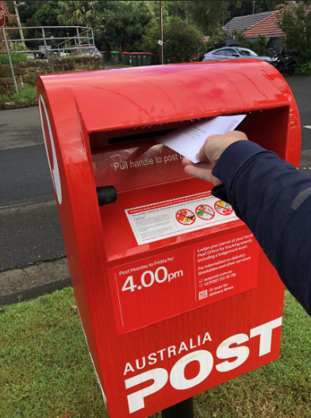
I need to take the white return envelope with my ballot paper sealed inside to an Australia Post mailbox. I don’t need to use a stamp.
I can ask someone I trust to help me with this.


When my white return envelope has been put in the mailbox, I have finished voting.

